PRODIGY DATA SCIENCE INTERNSHIP TASK 1
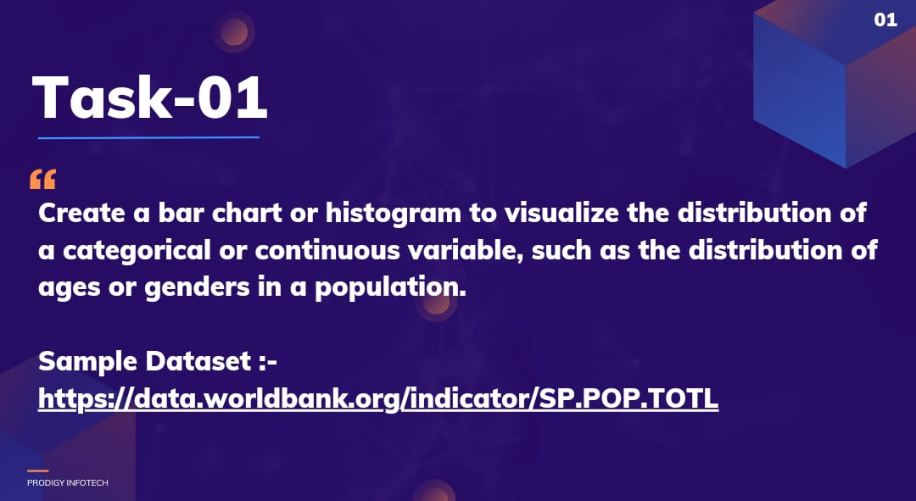

Population Data Visualization

Overview
This project involves analyzing and visualizing population data across different countries from the years 2010 to 2022. The focus is on creating bar charts to compare the populations of the top 10 and bottom 10 countries over multiple years.

Dataset
The dataset used for this project is the World Population Data, which includes:
- Country Name: Name of the country
- Country Code: ISO code for the country
- Population Data: Population counts for various years (e.g., 2010, 2015, 2018, 2020, 2021, 2022)

Tasks Completed
- Bar Chart for Top 10 Countries (2018-2022):
  - Created a bar chart visualizing the populations of the top 10 countries based on the population in 2022.
- Bar Chart for Bottom 10 Countries (2018-2022):
  - Created a bar chart visualizing the populations of the bottom 10 countries based on the population in 2022.
- Population Comparison:
  - Compared the populations of the selected countries across the years 2018 to 2022.

Requirements
To run the analysis and generate visualizations, you will need:
- Python 3.x
- Pandas library
- Matplotlib library

Conclusion
This project provides insights into global population distribution and highlights the disparities between the most and least populated countries over time. The visualizations can be used for further analysis and discussions on population trends.

